BIO-DATA
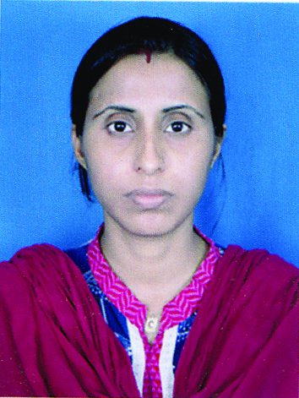
PERSONAL PROFILE
- NAME :- Mrs. PARAMITA BHATTACHARYA
- FATHER’S NAME :- Mr. BHANUDEB BHATTACHARYA
- HASBAND’S NAME :- Dr. MADHUSUDAN MUKHERJEE
- BLOOD GROUP :- AB+
- E-MAIL ID :- bhattacharyaparamita363@gmail.com
- PERMANENT ADDRESS :- VILL.- KURAN, P.O.- KURAN, P.S.- GHATAL
WEST MIDNAPUR
- COMMUNICATION ADDRESS :- H/O- GAUTAM MUKHERJEE
AT- ROCKET LANE, SCHOOL DANGA
DIST.- BANKURA(W.B.), PIN.- 722101
MOB.- 9434568280, 7384719886
- SEX :- FEMALE
- RELIGION :- HINDUISM
- CAST :- GENERAL
- DATE OF BIRTH :- 31/12/1982
- NATIONALITY :- INDIAN
- MARITAL STATUS :- MARRIED
- LANGUACE KNOWN :- BENGALI, ENGLISH, HINDI

EDUCATIONAL QUALIFICATION :
Examination Passed | Name of Board/ University | Year of Passing | Full Marks | Marks Obtained | % of Marks
Madhyamik | WBBSE | 1999 | 800 | 523 | 65.38
H.S. | WBCHSE | 2001 | 1000 | 514 | 51.40
B.Sc. (Bio. Science) | Calcutta University | 2005 | 1350 | 749 | 55.40
M.Sc. (Environmental Science) | Vidyasagar University | 2007 | 1000 | 600 | 60.00

EXTRA CURRICULAR ACTIVITIES : SINGING, DANCING, DRAWING.
DECLARATION :-
I HEREBY DECLARE THAT THE ABOVE INFORMATION IS TRUE TO THE BEST OF MY KNOWLEDGE AND BELIEF.

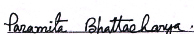
DATE : 20/06/2016
PLACE : BANKURA (SIGNATURE OF THE APPLICANT)

